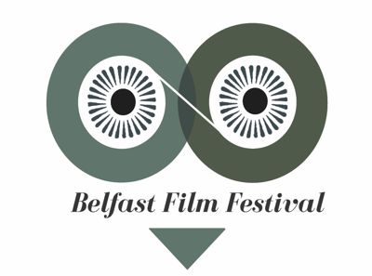
BELFAST FILM FESTIVAL
FREELANCE CONTRACT
ROLE: Marketing & Digital Content Coordinator
FIXED TERM: September 5th – Mid November 2022 (11 WEEKS)
FEE: £7,000 (negotiable depending on experience)
A hybrid working model is in place, office based (23 Donegall St, Belfast) with some working from home. The Co-ordinator will be based full time at BFF office during key delivery stages.
RESPONSIBLE TO: Head of Marketing
The Marketing & Digital Content Coordinator will be responsible for gathering, creating and coordinating the online content for the 22nd Belfast Film Festival. They will assist with all aspects of marketing for the festival including event management, publicity and PR, advertising and design, as well as festival administration and general festival duties.
Experience
- Minimum 3 years experience in a marketing role;
- Excellent experience of social media – developing social media plans and creating content for websites and social media platforms.
- The use of digital marketing tools.
It is desirable for the successful candidate to have an interest in working within a creative environment and an interest in.
Apply with full CV and cover letter to moyra@belfastfilmfestival.org by 19th August 2022.
SEE BELOW FOR FULL JOB DESCRIPTION

BELFAST FILM FESTIVAL
MARKETING & DIGITAL CONTENT COORDINATOR
JOB SPECIFICATION
KEY RESPONSIBILITIES
- Work closely with the Head of Marketing to deliver on comprehensive marketing strategy for the 22nd Belfast Film Festival.
Website
- Publishing and promoting up-to-date content.
- Creating content that engages, informs and entertains e.g. film reviews, blogs, recommendations.
- Keep content on website current and up to date with upload of news/photos/video content.
- Work with BFF team in relation to live streaming key events.
- Source images and publicity material.
- Plan and coordinate photography schedule.
- Up sell/cross sell events via cross-selling feature on our website as well as social media.
- Assist with programme upload to website prior to festival launch date.
Social Media - work with social media team members to:
- Recruit and oversee a (short-term) social media team
- Recruit bloggers/vloggers/film students who may be interested in attending the festival and creating blogs/vlogs on their experiences as well as live tweeting.
- Develop a social media plan for the 22nd Belfast Film Festival and ensure it’s implementation.
- Create social media content that reflects the personality of the festival.
- Ensure social media sites are efficiently maintained – Twitter/Facebook/Instagram/other.
- Analyse growth in social media interactions through regular assessment of Analytics data.
- Check film related websites to influence social media posts – include relevant detail e.g. film reviews, or quotes for films in programme.
- Run competitions with a sponsor/deals and discounts eatery/travel. Use of online sponsored adverts.
- Manage/oversee daily Instagram stories/tweets/FB Posts continuously throughout festival.
- Coordinate live tweeting throughout events e.g. BFF22 Launch, festival events.
E-marketing campaigns:
- Create an email marketing campaign that informs mailing of upcoming events.
- Co-ordinate festival e-marketing schedule alongside Head Of Marketing in the lead up to and including festival.
Online Systems:
- Manage and maintain the BFF photographic and video libraries for BFF22.
- Updating website free listings including festival profiles
- Seek online free advertising
Monitoring and evaluation
- Work with the Head Of Marketing to ensure all marketing information relating to the 22nd Belfast Film Festival is gathered for reporting purposes.
OTHER DUTIES
- Any other duties which may arise in relation to general festival activities

